WooCommerce Plugin for ALRAJHI

## About

This document introduces ALRAJHI payment plugin for WooCommerce 3.6.1. Subsequent sections of the document explains step by step, how to integrate the plugin to WooCommerce and use it.

## Target Audience

This document is useful for Merchants, who are going to use ALRAJHI plugin with WooCommerce for the first time or re-installing the plugin in WooCommerce.

## Merchant Prerequisites

* Hardware – Standard Web server with internet connectivity
* Software – PHP 7.2 / 5.6, Mysql, Apache (or similar web server), Wordpress and WooCommerce. WooCommerce must be pre-configured to execute checkout process.

## Merchant Integration Process

Caution: Always keep backup of your existing WooCommerce installation including Mysql Database, before installing a new module.

Install via WordPress plugin Installer:-

1. Login to WordPress Admin panel and goto Add New Plugin. Then click on Upload Plugin.

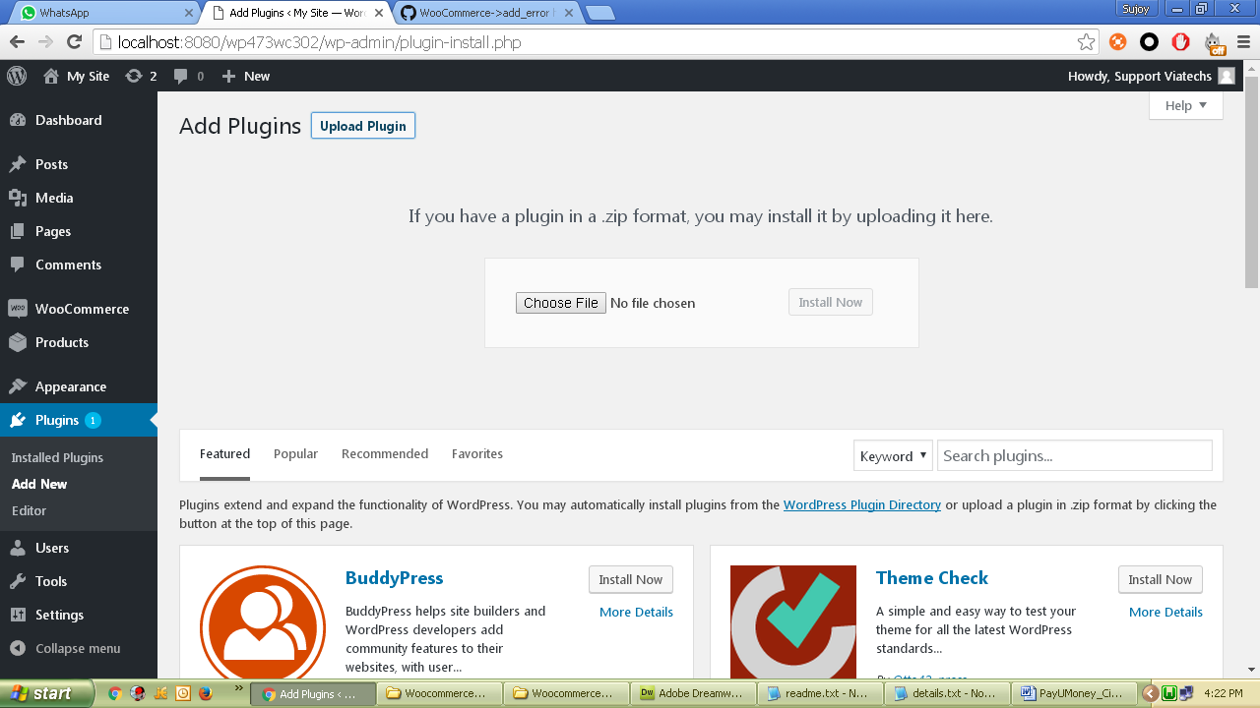

1. Choose this downloaded zip and click Install Now.
2. Activate plugin after successful installation.

Manual Installation:-

1. Unzip and copy ‘WooCommerce_v361_ALRAJHI’ folder from this zip and paste/upload it to <wordpress root>\wp-content\plugins folder.
2. Login to WooCommerce admin and goto Plugins.
3. Activate the plugin.

Configure Module:-

1. Login to WordPress admin and open WooCommerce Settings.

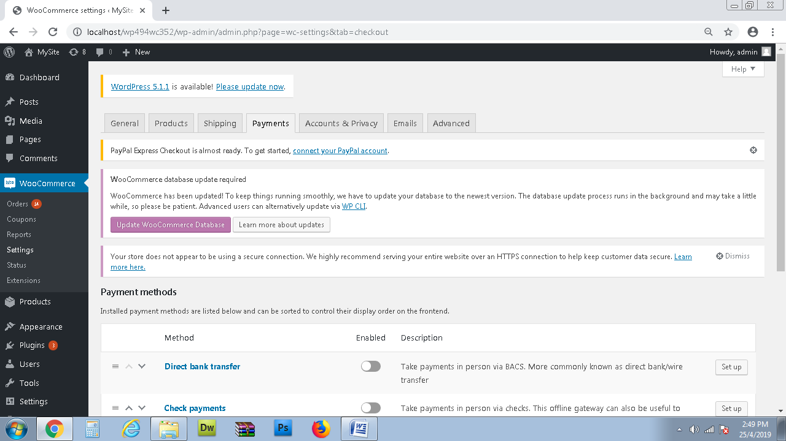

1. Click on Payments tab and then Settings button on right of ‘ALRAJHI’ plugin.

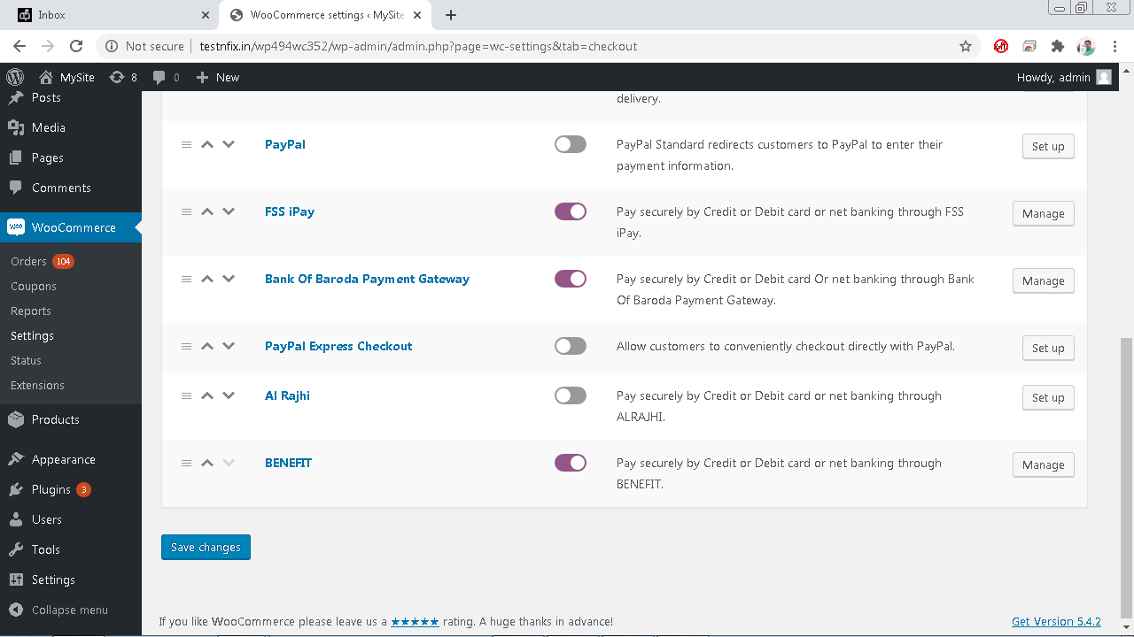

3. Click on Setup / Manage to configure

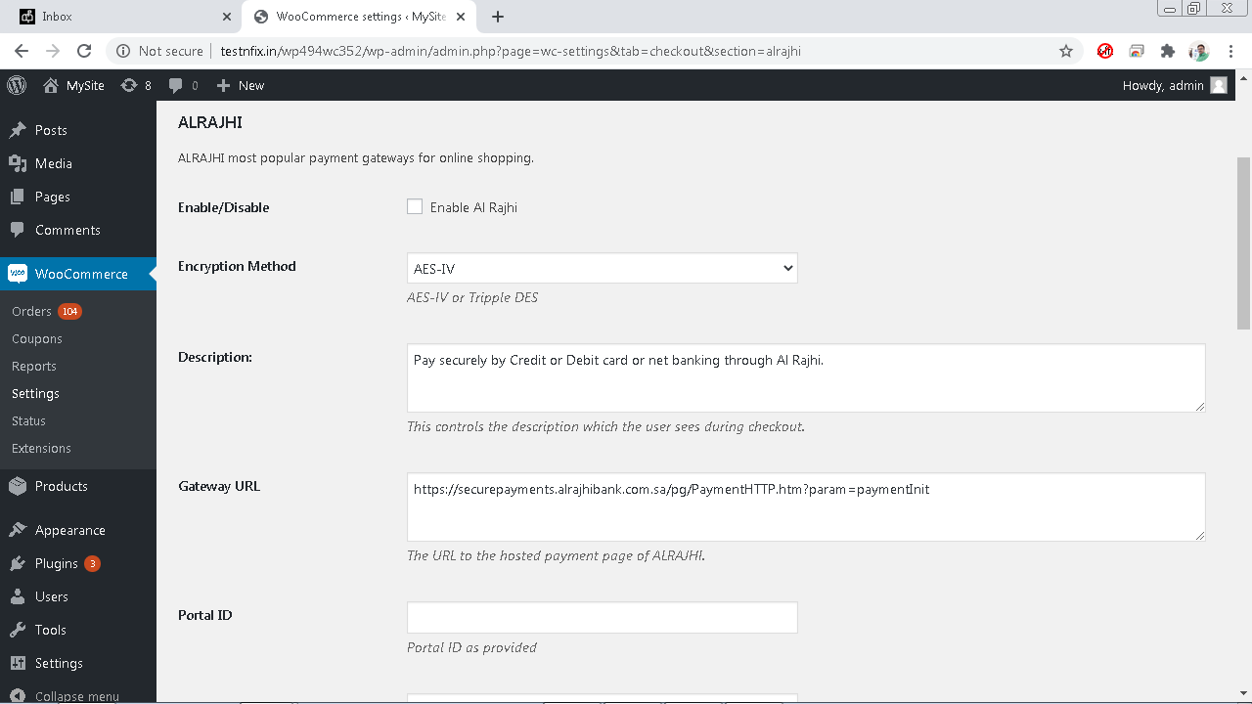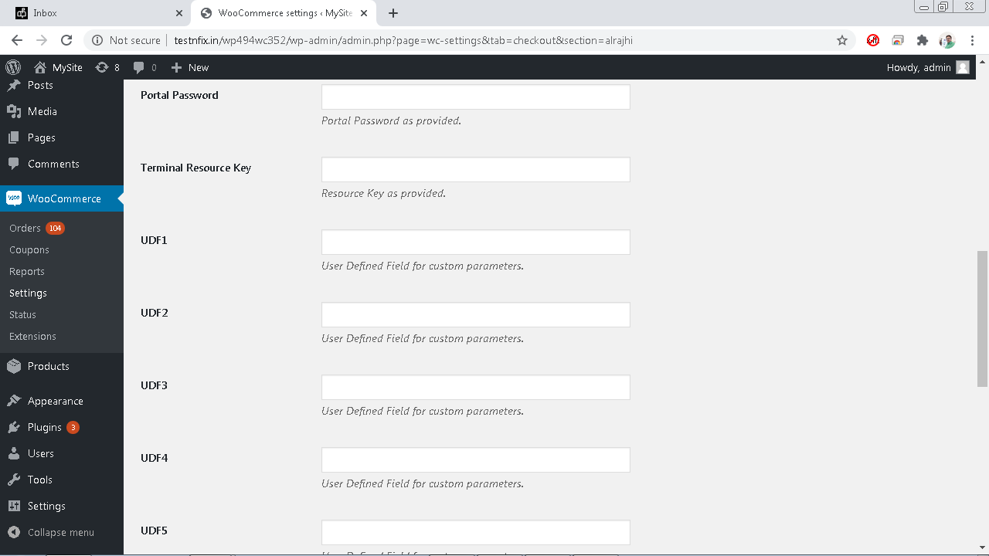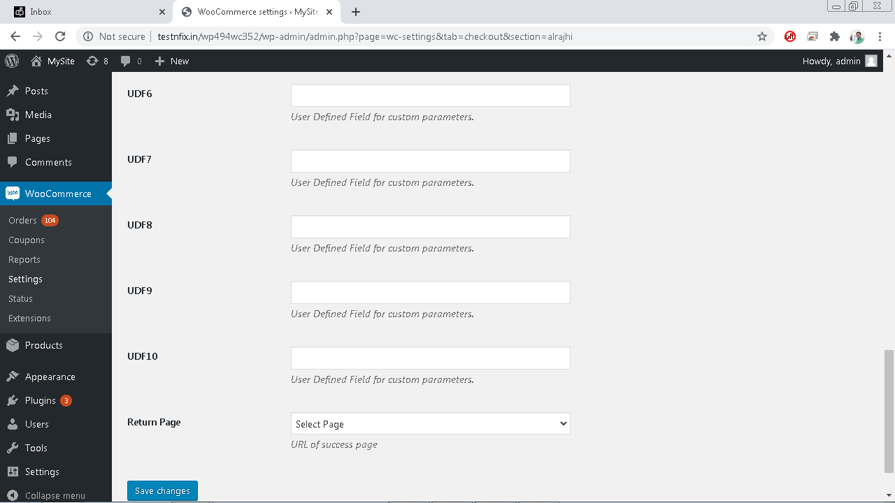

* + Enable/Disable – Tick to enable the module.
  + Encryption – AES / TDES as per requirement.
  + Description – Enter appropriate description to display at checkout.
  + Gateway URL – Test url is already set as default. For live, the url will be provided.
  + Portal ID – The ID as provided
  + Portal Password – The password as provided.
  + Terminal Resource Key – The key as provided.
  + UDF 1 to 10 to be filled in as per requirement.
  + Return Page – Use My Account as the default return page after payment response. You may create a custom page and select here. However, the custom page must contain appropriate WordPress / WooCommerce codes to show custom massages. Refer WordPress / WooCommerce development guide for custom pages.
  + UDF1 to UDF4 – This are fields to pass custom values to payment gateway as per requirement. Please consult iPay support for more information on these.

1. Now click save and customer will get ALRAJHI option during checkout process.

## Request / Response between Woocommerce and ALRAJHI PG

Add one product to cart and checkout with ALRAJHI

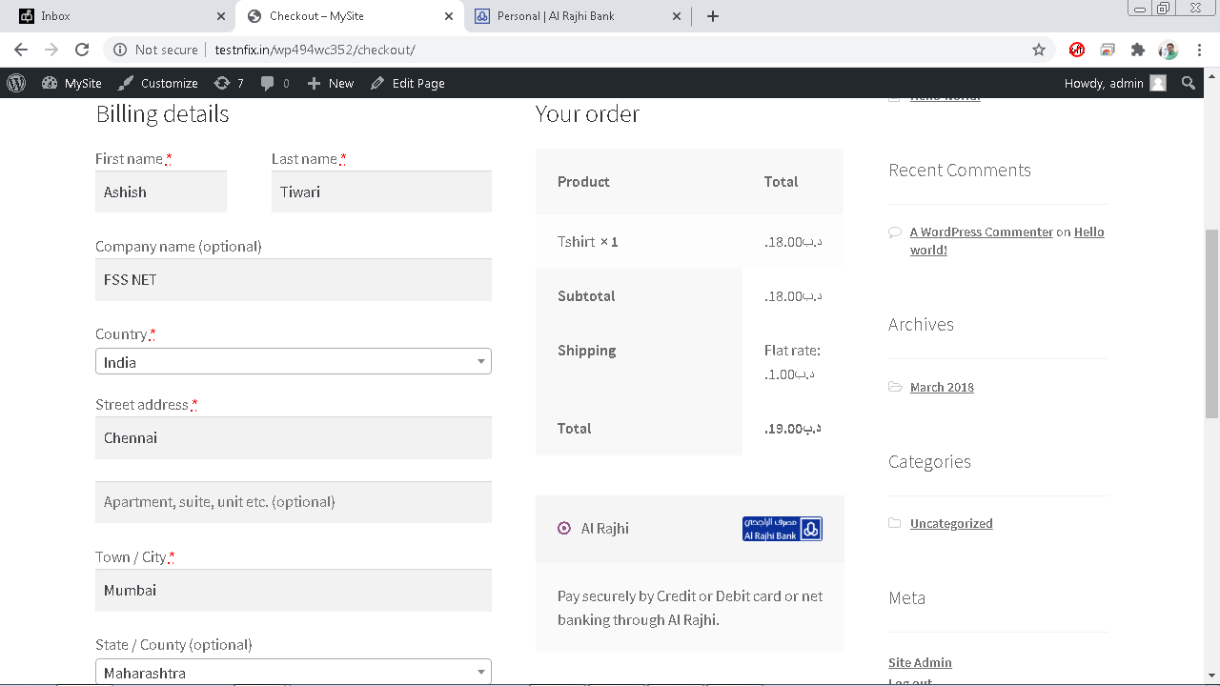

Complete dummy payment at ALRAJHI payment page and success response will create Order at WooCommerce.

